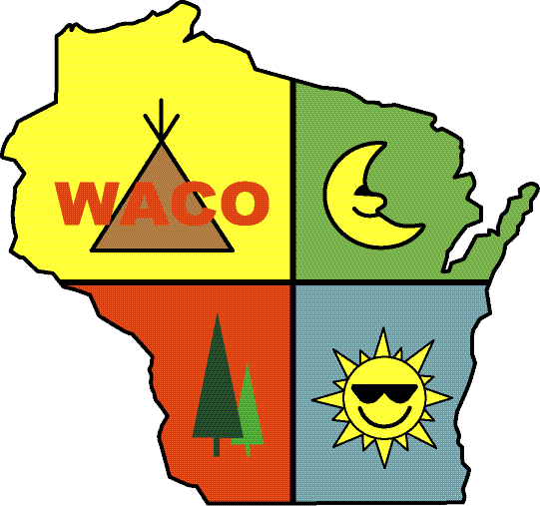
WACO 2019 Convention & Trade Show
March 13-17, 2019
Holiday Inn Hotel & Convention Center
1001 Amber Avenue
Stevens Point, WI 54481
715-344-0200

Campground Name _______________________________________________________________________________
Address ___________________________________________ City _________________ State______ Zip__________
Signature ____________________________________ Date ________________ Phone ________________________
Fax ___________________ E-Mail _____________________________________ Cell Phone ____________________

Please print names of registrants as you would like them to appear on badges.
1. __________________________ 2.__________________________ 3. ____________________________
4. __________________________ 5.__________________________ 6. ____________________________
7. __________________________ 8.__________________________ 9. ____________________________

WACO Member Convention Pass Options
Early Bird Price Pay before January 31, 2019 (Must be postmarked or verifiable)
Full Convention per person $200 x____ people =$________
Full Convention Out of State ARVC $250 x____ people =$________
Full Convention non ARVC $325 x____ people =$________

After January 31st, 2019
Full Convention per person $300 x____ people =$________
Full Convention OOS ARVC $375 x____ people =$________
Full Convention non ARVC Members $425 x____ people =$________

Expo Only $75 per person/per day ____ people x ____days = $_______

Total from Passes: $_______
ServSafe Certification (Must pre-register)
Please print names of registrants
1. __________________________ $75
2.___________________________ $75
3. __________________________ $75
4. __________________________ $75

Pool Certification Course (Must pre-register)
Please print names of registrants
1. __________________________ $100
2.___________________________ $100
3. __________________________ $100

Total from Certifications: $_______
Kids Kamp (Wednesday – Saturday)
**Rate for entire convention (No discounts for less days)
Kids Kamp Wed. thru Sat. $95 each x____ people =$________
Teen Program Wed. thru Sat. $95 each x____ people =$________
Non-registered Kids Per Day 50 x____ days x____ people =$________
Children’s Name, Age, T-shirt Size (list if specifically youth or adult)
5. ___________________________ ______ ______
6. ___________________________ ______ ______
7. ___________________________ ______ ______
8. ___________________________ ______ ______

1. ___________________________ ______ ______
2. ___________________________ ______ ______
3. ___________________________ ______ ______
4. ___________________________ ______ ______

Total from Kids Kamp: $_______
TOTAL: $_______

Total Amount Enclosed $ _______ Check # _________ Credit Card # ________________________________
MC ___ Visa ___ Expiration Date ________ Signature ________________________________________

Room reservations should be made directly to Holiday Inn & Convention Center, Phone: (715)344-0200 (Standard double Suites $78.00 King Suites $108.00, plus tax). Other Accommodations: Holiday Inn Express (Across the Street) same rates plus tax, includes Breakfast. Phone: 715-344-0000. Please mention that you are attending the WACO Convention or use code CAM
Other lodging options include: La Quinta Inn & Suites Call for pricing (715)344-1900
Reservations must be made by February 12, 2019 to insure these prices....No exceptions this year!

Complete and mail this form to: WACO – P.O. Box 228 – Ettrick, WI 54627
Phone: 608-525-2327 Fax: 608-525-2328

