Bada Boom or Bomb?

**How to be Successful at Your Next Trade Show!**

Ahhh the trade show - the excitement, the opportunities, the connections – and the ultimate waste of time and money if you don’t do things right! When is the last time you truly interacted with a potential client or prospect? I’m talking TRULY interacted. Not sent an email or newsletter with a link, not sent a text, but actually spoke with them to spark some sort of beginning to a partnership? With all the media and technological advancements, we’ve seen as a society, the amount of time we have to engage conversations is extremely limited! Here are a few tips and reminders to ensure your upcoming trade show trip is a successful one.

**The Big Impact of Booth Staffers**

The time it took to read the first sentence of this intro, is the same amount of time you have to make a “connection” with a trade show attendee. According to body-language expert Dr. Lillian Glass, people in live social encounters – such as a staffer greeting an attendee – used to have like four minutes to make an impression. Not anymore! "Today, that window for making a first impression has shrunk to **four seconds,** **and can be as little as four milliseconds in certain situations**," says Glass. So, what should your staffers be aware of?

**COMMUNICATION**

Doug MacLean, a staff trainer based in Columbia, SC advises, "Staffers need to be trained that a single expression or solitary gesture can halt any further contact with your exhibit and therefore your company just as easily as saying a wrong word.”

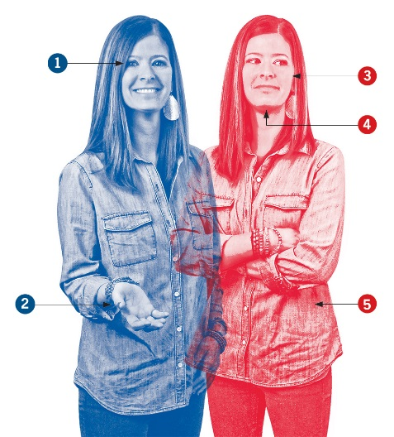You cannot overstate the importance of body language in training staffers for that initial encounter! Patti Wood, a body language expert and author of *Snap – Making the Most of First Impressions, Body Language, and Charisma* tells us that, "Everything from a staffer's handshake to head nod can also be the 'message' that attendees take home about your brand.” Based on these experts' research and experience, here are illustrations of the top 11 ways staffers' body language can sink your exhibit in the wink of an eye.

1. **Brows High**  
   Eyebrows held in a resting position conveys a lack of interest in others, and could discourage eagerness to engage in conversation or even enter the booth. Raising the eyebrows is perceived as a welcoming action that better prompts visitors to approach and engage.  Hike those brows up and be interested to talk to your attendees!
2. **Palm Readers**  
   Did you know there are 5,000 distinct hand gestures researchers have identified in body language? (Don’t feel bad, I didn’t know either!) Palms facing downward communicate a closed mind, and even disagreement with what the other person is saying. However, a palms-up gesture projects friendliness. Be friendly people 😊
3. **Anger Management**  
   Interactions with angry attendees can easily result in a devastating first impression, since many staffers at a booth would just shut down if Johnny Crabby Pants huffed in. However, that can infuriate the upset party more because it suggests a lack of concern. Mirror the visitor by closing and flattening their lips, suggesting that you empathize with the guest. (Hint: You don’t have to actually empathize to suggest it with your body language.)
4. **Chin Music**  
   An upward-facing chin conveys the impression – figuratively and literally – that staffers are looking down their noses at a guest. Keep your chin pointed down toward the floor showing guests that you are meeting them on equal terms.
5. **Leaning Out**  
   Leaning away from visitors, with body and feet pointed at an extreme, almost perpendicular angle away from them says two things: 1. I don’t want to talk to you, and 2. I can’t wait to get out of here. Tilting the body and feet only slightly away from visitors, with arms in a relaxed position establishes a more personal connection.
6. 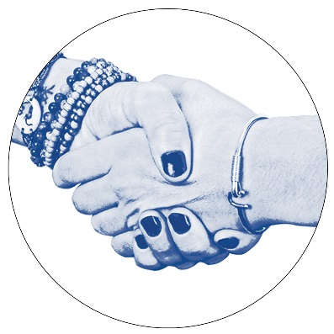**Shake It, Don't Break It**  
   Research suggests that it takes an average of three hours of continuous face-to-face interaction to reach the same level of rapport a booth attendant can achieve instantly with a handshake. But crushing an attendee's hand and/or pumping it more than once during a handshake is a display of dominance that can border on bullying.
7. 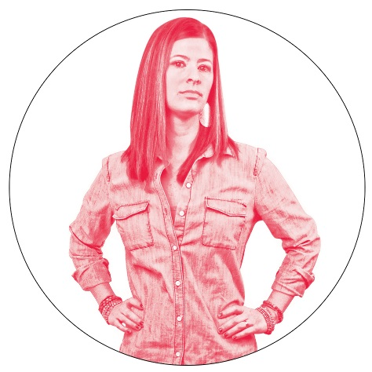**Forgo Full Frontal**  
   Check out this picture…doesn’t she look to be creating a human barrier to prevent visitors from entering the exhibit? Not inviting in any way! Instead, angle your body slightly away from approaching attendees, suggesting vulnerability and increasing accessibility to the booth.
8. 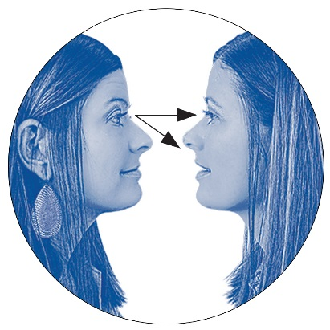**Balance Your Eye Contact**  
   Did you know not making eye contact can suggest a sense of dishonesty? Maintain eye contact in the ol’ “eye-nose triangle” for roughly two-thirds of your encounter with a booth guest. Any more than that ratio can feel like you’re looking a little TOO long, if you catch my drift.
9. 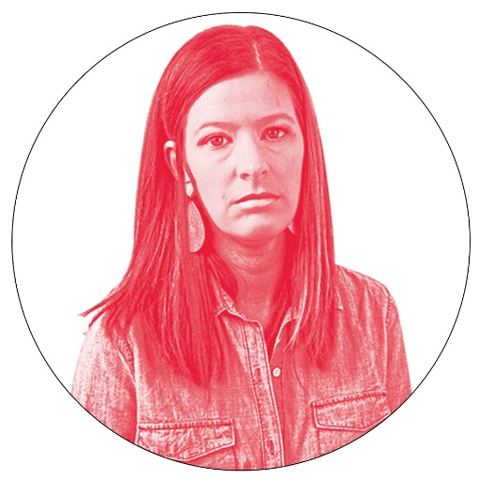**Cold Shoulder**  
   Slumped shoulders are a HUGE no-no at the trade show. The posture broadcasts weakness, pessimism, and a lack of confidence. Shoulders thrust back signify the opposite – strength and a positive outlook that appeals to visitors – and create the impression that your booth is important to visit!
10. 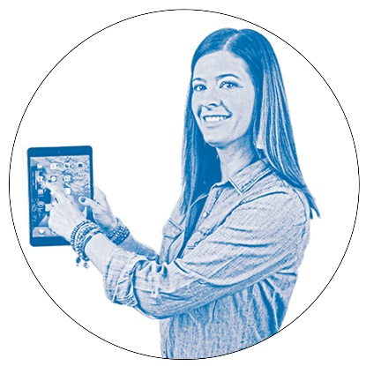**Angling for Position**  
    When showing attendees, a product demonstration or something on a screen, angling away from the guests and facing the product stops any connection from forming. Instead, imagine the screen/product, guests, and themselves as three points in a triangle, and position yourself so you can look at the two points (guests and screen/product) simultaneously.
11. 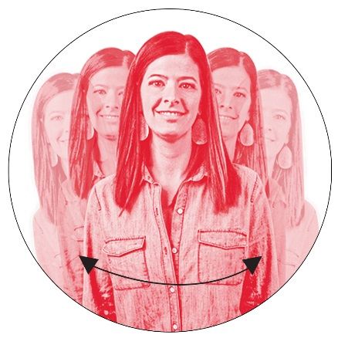**Hold Steady**  
    Shifting from side to side during a conversation implies your attention is otherwise engaged, and that you can’t wait to move away from the attendee as quickly as possible. Standing still, on the other hand, suggests full focus on the person in front of you, and that you’re willing to devote time and attention to have a conversation.

**GENERAL REMINDERS:**

* Interaction is key – I think we covered that above, but in case you missed it!
* Be Active on Social Media
  + Invite attendees to stop by your booth to enter a contest or watch a demo
  + Do a LIVE feed with an attendee who just won or is asking great questions/seems fun
  + Include your booth number if and if there is an event hashtag, be sure to include it
* 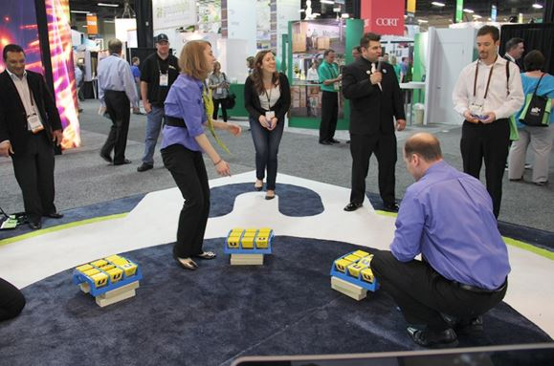Provide Giveaways or an Activity
  + Everyone loves to be a winner – you may opt to have smaller items that include promotion of your business, and a drawing for something larger
  + Remember to play to your crowd – for example, a basket of sugary snacks and chips may not make the most sense at a convention geared toward healthy living.
* Secure contact information
  + Use your giveaway to obtain business cards
  + Take images of names/contact information to avoid losing it
  + If the trade show includes scanning options, set your booth up and take advantage of it!
* Follow up
  + Conversation at the show are all fine and dandy, but will have less impact over time if you don’t follow up
  + A quick email or phone call to all contacts you gather makes a huge impact – take the time to make that prospect feel special, as you never know when they may need your services!