Glampin’ is the Life for Me!
While the idea of camping is so nostalgic, with its campfire lights, sweet smores and outdoor games, some people immediately think of mosquitos, sleeping on lumpy dirt piles, and food that is barely edible. There are so many ways to enjoy the outdoors and we are lucky in Wisconsin to have access to so many campgrounds with lodging options! The days of packing up essentials only to pile into a tent riddled with mud and shower under a strung-up hose are long gone…well I mean, those are still options should you prefer!
If you love the idea of camping, but not the pain it can cause in your lower back, “Glamping” may be an option for you. Here are some ways to get your glamp on!
- Sassy Shelters
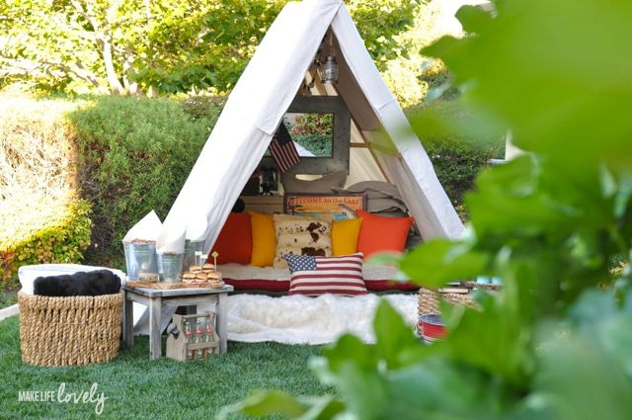
Drop Cloth and Wood. That’s all you need to create an A-Frame tent like the one shown here from Make Life Lovely! I’m here to tell you, I’m the Queen of Pinterest fails, but even I could follow some of these directions. Maybe try a smaller one for your kiddos first, for inspiration.
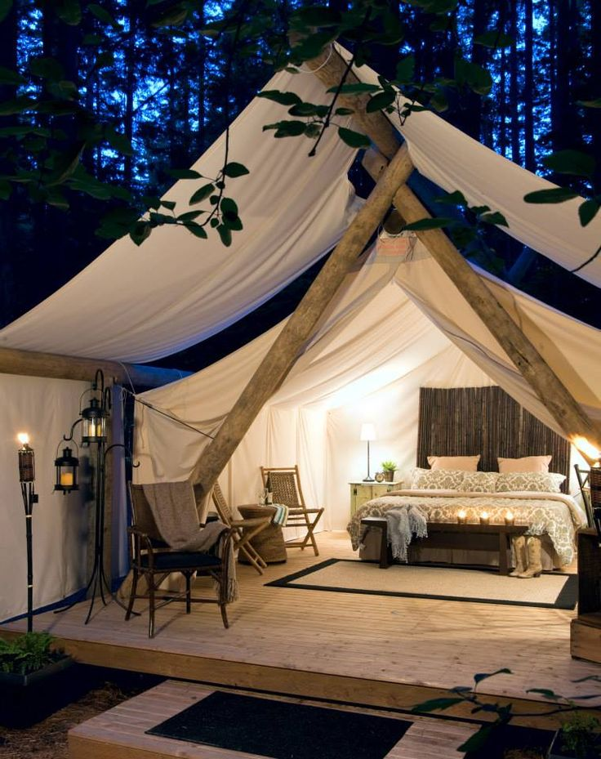

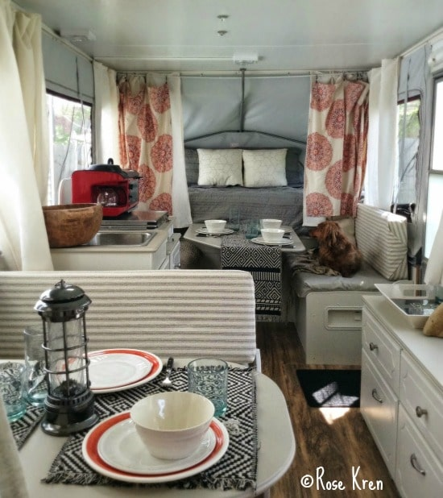
If you’re a pro and have permanent or seasonal space to work with, go big! Check out this amazing bedroom set up from Homedit, complete with platform deck and seating area.

Of course, if you already own an RV or pop-up camper, you can still glamp! Rose Kren shared her pop-up camper remodel on The Pop Up Princess and it is so chic! This is also a great example of how you can use accent pillows and décor to really make your home away from home cozy. Check out the table lantern and curtain divider in the back!
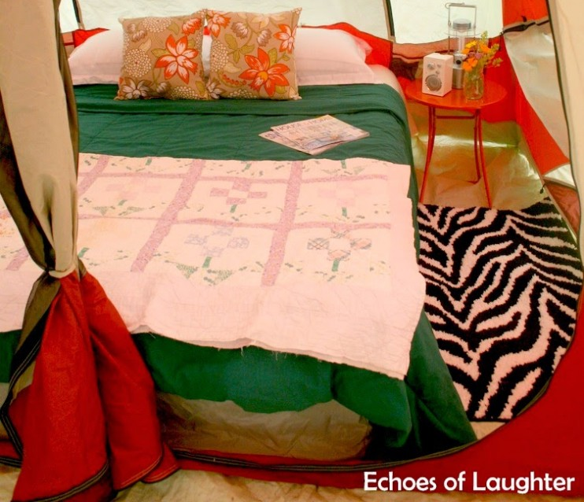
- Comfy Bedding
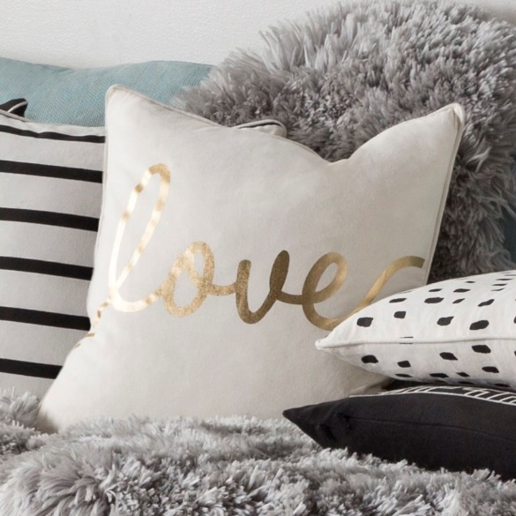
Ditch the sleeping bag on the ground and get an actual good night’s sleep with better alternative. If you haven’t invested in a portable bed yet, now is definitely the time to check one out. Get off the floor with an air mattress and foldable bed frame that can be put away for easy storage. This one shown from Echoes of Laughter includes sheets and coverlet making it feel just like home.

Be sure to fluff things up with comforters, blankets and accent pillows. If you’re glamping, the days of the sleeping bag with your feet twisted up like a pretzel are long gone. If you love your pillows at home, you love them just as much in your time away from home.
- Great Food
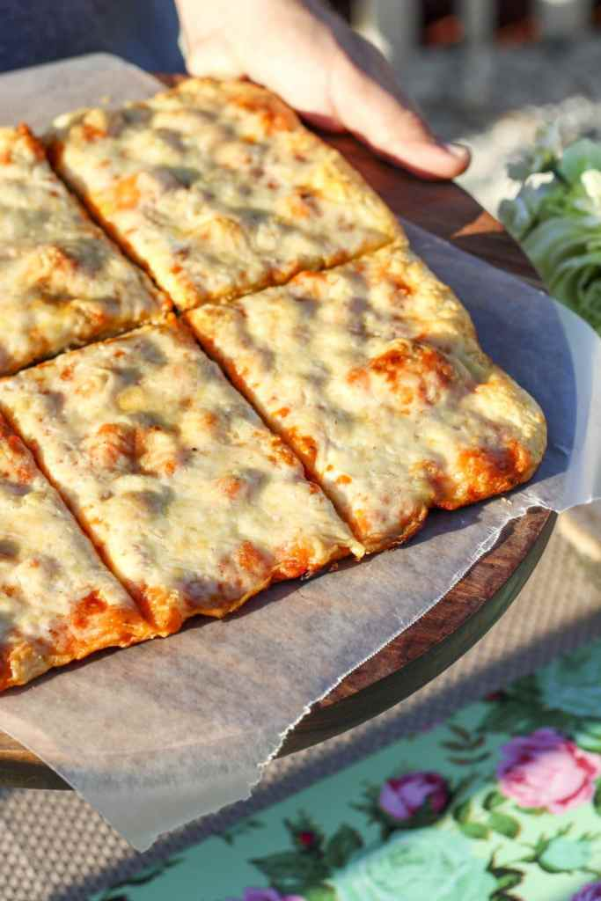
Alright we’ve got the bedroom set to go, but what about the kitchen? I don’t know about you, but whenever I’m traveling, even if its to the backyard, my first question is, “When do we eat?” Followed closely by, “What are we having?” Its fun to roast hotdogs and marshmallows by the fire, but that doesn’t mean you have to resort to eating the dog that fell into the fire – you know the one you rub the ash off of and still put in a bun? There are a couple of essentials for even basic level glamping when it comes to food:
- Bring Spices – If you season at home, its say to say, you’ll want to season while you camp. If you’re going to fire roast a loaf of bread, why not glamp it up with some amazing dipping sauces and oil?
- Tin foil – Tin foil should be in everyone’s camping gear no matter what style of camping is being done. It’s the mother of all make-shift cooking utensils. If you break or forget something, tin foil has you covered…ha ha, get it? I’ve made lids, stands, strainers and plates out of just regular old tin foil. Was it pretty? No, but it did the trick in a pinch! Look this grilled pizza, made on, yep you guessed it, TIN FOIL!
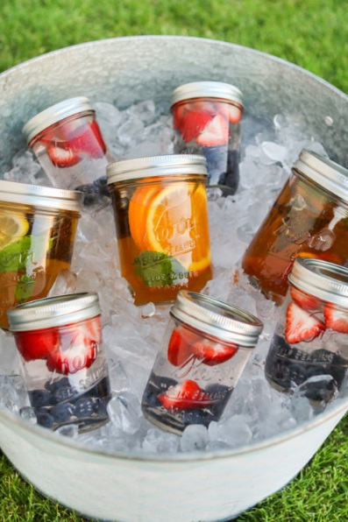
- Breakfast hack – don’t bother bringing the carton of eggs that could break in transport. Crack eggs into a mason jar at home and pop on a lid for safer storage in your cooler. Super easy way to shake out onto a griddle for over easy or of course, scramble in the jar!
- Beverages that look so pretty – another use for mason jars is to create pre-made cocktails or healthy juice options for the kids! You can prep ahead at home and place them in an old-fashioned tin with ice for that extra glamping touch.

- Décor to Die For
Additional pieces to really say you’re “The Glamper” include final touches with your décor.
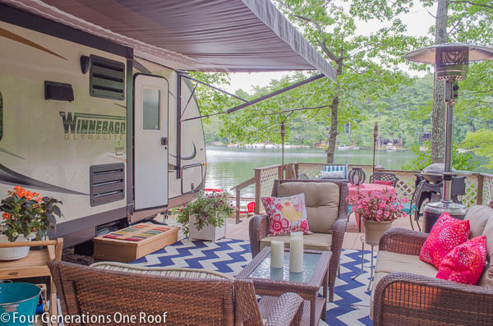
Jessica Bruno from Four Generations One Roof, shows us here that your deck at the campground can be just as inviting as the patio at home!
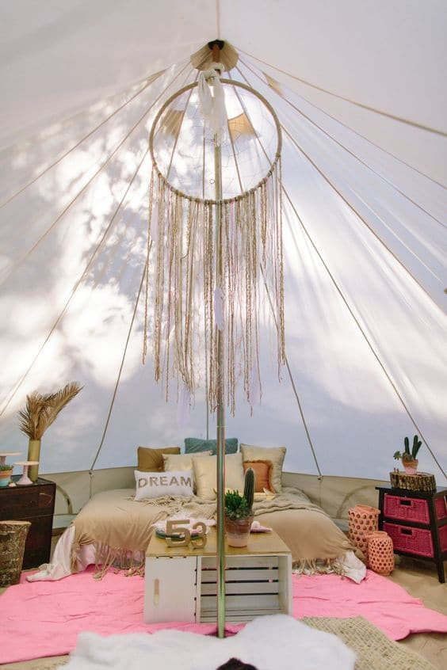
Lights, tables and accent pieces are HUGE when glamping. Checking out this amazing tent center piece from Stout Tents!

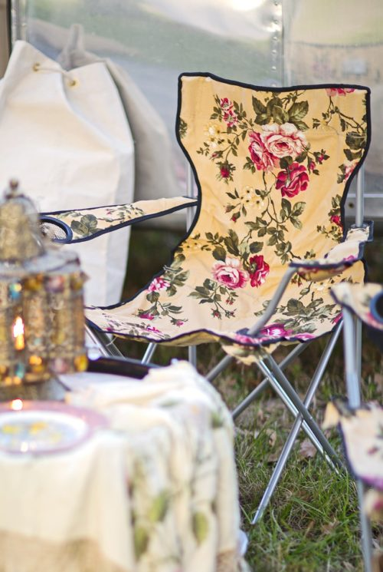
Gypsyville has some amazing chairs, that you can use when glamping and still take to soccer games.
Whether you’re creating a space outside for those to gather, or you’re providing that lighting people will be talking about, the options are limitless. Your style at home doesn’t have to end there and can follow you outdoors!
Some of these ideas may be over the top for you, and that’s ok! You don’t have to be 100% all-in to glamp…bring whatever supplies you need to enjoy your time, while still enjoying the outdoors.

