

FALL TOURS/WORKSHOP

**September 18 & 19, 2018**

**Host Campground:**

**Riverbend RV Resort**

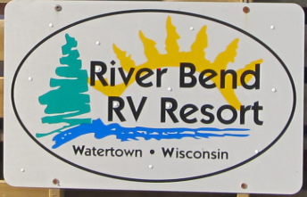

Your Host: Kris Swisher

Address: W6940 Rubidell Rd

Watertown WI 53094

Phone: 920-261-7505

Email: [info@rbresort.com](mailto:info@rbresort.com)

Website: [www.riverbendrvresort.com](http://www.riverbendrvresort.com)

Lll

**Fall Tours/Workshop Itinerary**

**Tuesday, September 18, 2018**

Host Campground: River Bend RV Resort

8:30 – 9:00 am Registration in Restaurant (Big Red Barn)

9:15-10:45 am WACO Board of Directors – Advertising Committee

WACO updates & ideas – Gilbert Brown Foundation update

10:45 --12:00 pm Tour of Riverbend RV Resort

12:00 – 1:00 pm Lunch at River Bend Benderz Bar and Grill

Sponsored by Coverra Insurance & Secura

Build your own sandwich & chips

1:00 pm – 2:00 pm Preparing for the Future- John Jaszewski

2:10 pm Leave for tour

3:00 pm Tyranena Brewing Company, 1025 Owen St, Lake Mills, WI 53551

Phone 920-648-8699Lake Mills 18 minutes from River Bend tour

Microbrewery with a taproom & seasonal beer garden – we will have a private tour with an actual brew master! Price finalized soon

|  |  |
| --- | --- |
|  |  |
|  |  |
|  |  |
|  |  |
|  |  |
|  |  |
|  |  |

4:45pm Cocktails at Rivers Bend

Best ideas for activities and making money – cracker barrel with prizes!

5:30 pm Dinner Broasted chicken, pork chops, mashed potatoes, salad bar. Cost ____

After Dinner Social Hour

Camp at River Bend RV Resort

Call Kris @ 920-261-7505

Free camping and discount cabins

**Local Motels Fun Stuff**

**Holiday Inn Express Johnson Creek Mall**

101 Aviation Way, Watertown, WI 53094 Right off I-94

920-262-1910

**Country Inn and Suites The Octagon House Museum**

725 Paradise Ln, Johnson Creek, WI 53038 **& First Kindergarten in WI**

920-699-2800 919 Charles St, Watertown, WI 53094

**\*\* Next morning** - 35 minute drive to Whistle Stop in Marshall, WI (from Watertown if you stay over)

**Fall Tours/Workshop Itinerary**

**Wednesday, September 19th**

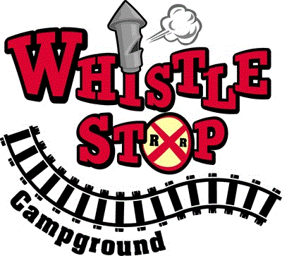9:00 -11:15 am Whistle Stop Campground

Hosts: Bud Styer and Dana Voit

114 Whistle St

Marshall, WI 53559

**30 minute drive to De Forest



12:00 – 12:30 pm We will be having lunch at Madison KOA

Covera Insurance Secura Insurance

12:45 – 1:45 pm Tour Madison KOA

Host: Terry Bernatchy

4859 Cty Rd V

De Forest, WI 53532



** 20 minute drive to Lodi, WI

2:15 – 3:15 pm Smokey Hollow Campground

Hosts: Bud & Dianne Styer

W9935 McGowan Rd

Lodi, WI 53555

3:15 pm Goodbye Everyone! See you October 2nd & 3rd!

Thank you for joining us and thank you to the hosts

**Fall Tours/Workshop**

**Please pre-register:**

Phone: 608-525-2327

Fax: 608-525-2328

Campground Name: _____________________________

# of people attending: ________

You are welcome to bring family and employees. The fee is the same if you have 1 or 20 members from your campground.

**WACO Member Fee:** **Non Member Fee:**

$40 one workshop $55 one workshop

$75 Sept/Oct workshops $105 Sept/Oct workshops

** Meals & Motel costs are not included

September only $_______

October only $_______

Both Seminars $_______

Send payment and registration form to:

WACO

PO Box 228

Ettrick, WI 54627