Theme:
Spring Fling

Decorations: April Showers, Spring Flowers, New beginnings, Adventurous thoughts of upcoming Summer. Balloons, Sunrises,

Games & Activities:
- Egg throwing contests.
- Egg hunt
- Races
- Walk-a-thons
- Bunny Hunt

Kids Activities:

- Races
- Nature Walk
- Schedule a softball game
- Volley ball Marathon

Crafts:

BATH SALTS FOR MOM
Submitted by: Anne Freeman, a teacher in Winston Salem
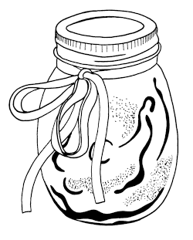
A scent-filled gift for mom ... from the heart.
"This is an inexpensive project. Most materials can be found at a drug store. Enjoy!"
Anne Freeman

What You Need:
- Epsom salts
- perfume
- glycerine
- food coloring
- bags or baby food jars

What You Do:
- Pour epsom salts into large bowl.
- Add about 3 tablespoons of glycerine, about 1 tablespoon of perfume, and stir.
- Add either red or blue food coloring to tint pink or light blue.
- Stir.
- Put into bags or jars. Can be put into cards.
- Add a note about enjoying a bath using 2 tablespoons of bath salts.

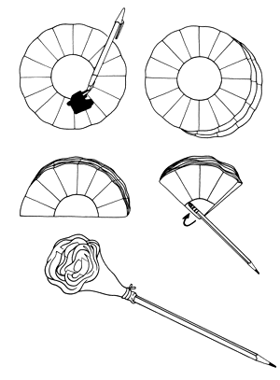
COFFEE FILTER FLOWER PENCIL

Objectives
A nifty, thrifty idea for mom.

What You Need:
- coffee filters
- big washable color markers
- spray bottle of water
- thread
- pencil

What You Do:
- Mark on 2 or 3 coffee filters with the washable markers, big color blotches are ok.
- Place the filters flat and stack them
- Fold them all together (as shown in the diagram), and roll the filters at the fold around the eraser end of a new pencil. Wrap with string to secure.
- Push pencil into a holder and spray with water.
- Watch the colors fade into each other.
- When the flower dries, spray lightly with Moms perfume and fluff. She'll have a fancy flowered pencil for her desk.

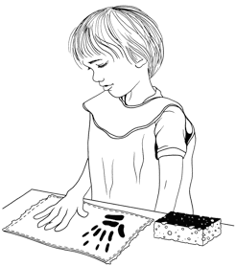
HANDPRINT DISHCLOTH

Objectives
Creating a memory of little hands that mom can keep with her forever.

What You Need:
- A solid color dishcloth --- yellow, green blue ... your choice. (you can buy sets of them at larger department stores for very little money).
- Fabric paint (this is important because you want a paint that will last through washing machine trips).
- Trays for holding paint.
- Paintbrushes or sponges.
- A covered work area.
- Hands (or even feet?!)

What You Do:
- Here's the easy part, children paint their hands using a sponge or a paintbrush and make a handprint on the washcloth.
- Think contrasting colors ... in other words, if you have a dark colored dishcloth, then use a light colored paint and visa versa.
- Use a paintbrush to write the date on the corner of the dishcloth. (The child's name can go there too).
- You can get really creative and try this on oven mitts, an apron (visualize a "bouquet" of hand and footprints all over mom's apron.) The sky's the limit.
- *Make sure you follow the directions for setting the fabric paint (the direction will be on the paint container). That way the washing machine will deliver mom back the same wonderful handprints wash after wash.

Here is a poem to go along with the dishcloth.
Sometimes I might upset you
Just because I'm small
By leaving fingerprints of mine
On a table, chair or wall.
But everyday I grow a bit
And I'll be big one day
When all my tiny fingerprints
Have long been cleaned away
So keep these prints of my two hands
To help you to recall
Just how big my fingers were
That time when I was small.

PAPER BAG or FABRIC PONCHO
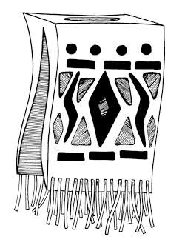
For Cinco de Mayo on May 5th (or any day of the year), have yourself a special day complete with Mexican food and Mexican clothes like brightly colored ponchos. Cinco de Mayo is a Mexican national holiday. It marks the victory of the Mexican Army over the French at the Battle of Peubla on May 5, 1862.

Paper Bag Poncho

What You Need:
- Large Paper Grocery Bags
- Bright markers
- Paints
- Crayons
- Paint brushes and water

What You Do:
- Cut a hole in a paper bag so that your or your child's head can fit through.
- Cut slits up both sides of the bag.
- Decorate the paper bag poncho with brightly colored markers or paints or crayons.
- Try a waterpaint wash technique, whereby you draw on the paper with crayons and paint a light wash of paint overtop.
- You can also glue bits of fabric scraps onto the paper bag as well.
- Have a look at some real ponchos for inspiration.

Fabric Poncho:

What You Need:
- 3 ft square of blanket or heavy fabric or old bed sheets
- scissors
- waterproof fabric makers

What You Do:
- Fold the fabric in half.
- Cut a v-shaped slit in the middle of the fold. The slit should be large enough to let your head push through it.
- Cut fringes at the bottom of the poncho.
- Draw geometric designs on the bottom edge.

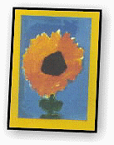
FLOWER POWER
Springtime is flower time so why not fill your home or classroom with creative celebrations of nature in all of her colorful glory. Here are a number of ways for you to bring flowers and springtime into your home or classroom ... and get a head start on Mothers Day too.

PAINT A FLOWER
...Just one flower. Its fun ... its easy ... it makes you feel good.

FLOWERY NAPKIN RINGS
Take a paper towel tube, cut it into small sections (2"-3" long). Paint bright beautiful flowers on the tube pieces. Coat the finished product with a water-based sealer.

APRIL SHOWERS
Gather some old umbrellas (or buy some inexpensive new ones) and paint wonderful flower designs, suns, raindrops, sponge prints, or butterflies all over the umbrella. Its best to use fabric paint for this project but you can also use tempera paint with a touch of glue.

BUTTER-FLOWERS
Combine butterflies and flowers for a super springtime artwork. Begin with a large sheet of paper (22" x 30") and divide into several squares and rectangles of every size. Then, fill the geometric spaces with bright butterflies and bold flowers. Use paint, markers, colored pencils or crayons or a combination of all media. You can even glue cut-out shapes onto your collage. Be sure to repeat the same colors throughout your butterflower collage.

