Theme:
“Seuss on the Loose”
Dr. Seuss and friends will be on the loose this weekend! Cat in the Hat, Horton the Elephant, Mazie La Bird and the Grinch will all be on hand to bring out the kid in everyone!

Background info:
The proud poet
What was Seuss' greatest achievement? His success at teaching children to read, to love language and to use their imaginations. He always said The Cat in the Hat was "the book I'm proudest of, because it had something to do with the death of the Dick and Jane primers."
Not a bad epitaph: He slew Dick and Jane.
Colorful
Originally, his palette was limited, says Audrey Geisel, who helped him expand his color horizons. "It started with primary colors — just black, white and red," for The Cat in the Hat character. "And as the years went on, around The Lorax, it moved into mauves and lavenders, purples and grays."
And everyone thinks of the Grinch as green, right? Well, Cohen says, he wasn't; he was black and white with a red Santa-like sweater. But the Grinch turned green when Geisel hooked up with animator Chuck Jones to make How the Grinch Stole Christmas! for TV. And the rest is history.
The child within
He had no children of his own, though he became a stepfather to two grown daughters when he married Audrey. But it didn't matter, as he often said: "You have 'em, I'll amuse 'em." Many of literature's most beloved children's authors — Lewis Carroll, Beatrix Potter, Edward Lear, Maurice Sendak — did not have children.
Geisel's biographers say he retained a good deal of the child in him as an adult, which might be one reason why kids loved him.
"He had a sense of mischief. He distrusted the grown-ups," Nel says. "He used to say, 'I don't write for children; I write for people.' "
Take it from the top
No doubt about it: The guy liked hats. Is there anywhere a chapeau more recognizable than the Cat's red-striped top hat? And he wrote a whole book about a boy and his hats, The 500 Hats of Bartholomew Cubbins, who was sentenced to death by a foolish king because he had too many.
Geisel had a couple of hundred hats of his own, Cohen says; in his later years, he loved to have guests wear zany hats to parties at his home in San Diego.

Weekend Family Fun
This weekend could feature performances of “Seuss on the Loose”(skits of the Sneeches, Gertrude McFuzz and Cat in the Hat by teen volunteers) OR “Celebrating Dr. Seuss with Original Song and Storytelling”
Decorations:
Cat in the Hat craft, cookies, and a special visit by the costumed character at the park

Games & Activities:

- Recruit some campground visitors to do special readings like “Cat in the Hat” for kids
- Have someone dressed in a Cat in the Hat Costume

Kids Activities:

- Book marks – Cut and Fold
- Make a Hat
- Make some “Cat in the Hat” edible hats

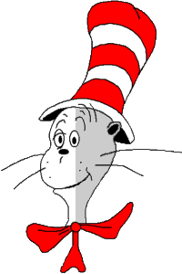 Name______________________

Cat in the Hats
Each kid will need the following pieces to make a Cat in the Hat...
3 1/2 inches by 1 1/2 inches black (to cut whiskers)
1 inch by 1 inch black (to cut a circle nose)
4 1/2 inches by 6 inches black (to trace/ cut the head)
4 inches by 5 inches white (to trace and cut the face)
hat (copied on white paper so they can color 3 strips red and cut it out)
Cat in the Hat Wearable Hats
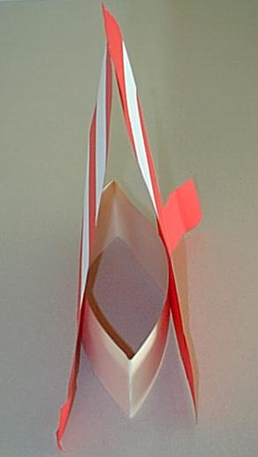
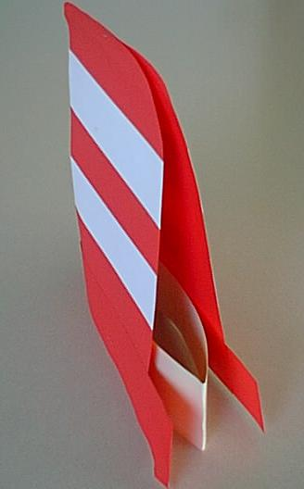

Each student will need the following to make a Cat in the Hat Wearable Hat....
1 sentence strip (for the headband)
2 pieces of 3 inches by 12 inches red (for the brims)
2 pieces of 9 inches by 12 inches red (for the main portion of the hat- Students can either trace a pattern and cut or they can round the top two corners.)
4 pieces of 9 inches by 2 inches white (for the stripes- Students glue these on and then trim the excess hanging from the edges.)
Once kids have cut and glued the construction paper portions of their hats, they will need an adult to size and staple their headband, to staple the top, and to staple the bottom of their hat to the headband in two places.

Cat in the Hat Edible Hats
Each child will need...
1 Ritz cracker
3 Red Lifesavers (gummy ones would work best)
small amount of white frosting or cream cheese
Kids assemble their edible cat's hats by placing the Ritz cracker on the bottom, spreading the white frosting, placing one red lifesaver, spreading more frosting, etc. (alternating the frosting and lifesavers). End up with a miniature Cat in the Hat hat!

'Cats in Hats' Companion Rhyme:
Introduce the rhyme: Begin by teaching the rhyme orally as a fingerplay. Then, introduce the word chart and have kids join in the reading by echo reading.
1 cat on a sunny day put on his hat and went out to play
2 cats when the sky was blue put on their hats and went to the zoo
3 cats on a rainy day put on their hats, but had to stay
4 cats when the snow came down put on their hats and went to town
5 cats on a windy day put on their hats and blew away

