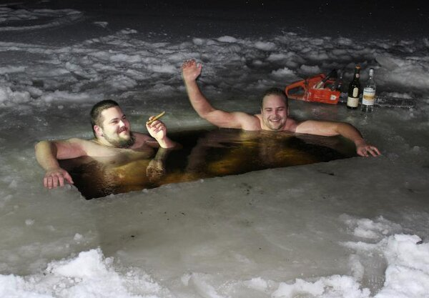

SHALLOW RIVER

ICE SWIMMING RESORT

RENTAL AGREEMENT FOR RECREATIONAL EQUIPMENT

**READ BOTH SIDES OF THIS AGREEMENT BEFORE SIGNING IT!**

I agree to rent the Equipment identified in this Agreement, and to abide by the requirements and rules stated in this Agreement and by the Rental Center staff. I agree to all the terms and conditions on both sides of this Agreement.

|  |  |  |  |  |
| --- | --- | --- | --- | --- |
| RENTERS | Name | Campground Unit # or Address | Age if less than 18 | Relationship to person signing |
| Primary Renter |  |  | Driver’s License # |
|  |  |  |  |
|  |  |  |  |
|  |  |  |  |

|  |  |  |
| --- | --- | --- |
| EQUIPMENT  RENTED | Equipment Any User May Operate | Equipment Adults Only May Control |
|  |  |
|  |  |
|  |  |
|  |  |

THIS AGREEMENT INCLUDES ALL THE TERMS AND CONDITIONS STATED ON THE OPPOSITE SIDE OF THIS PAGE.

**FOR YOUR SAFETY AND PROTECTION OF OTHERS, ALL RENTERS MUST FOLLOWING STANDARDS OF CONDUCT**

**AND BE ABLE TO SAFELY HANDLE THE EQUIPMENT**

Only the Renter is aware of their physical abilities and limits, and those of others in their group. If a Renter has any questions or needs information about the strength, coordination, balance and other skills needed to use equipment, the Renter is responsible to ask staff at the Rental Center. The Rental Center does not evaluate the Renter’s abilities, but only shares information about the equipment. The decision whether a Renter is capable of using equipment is solely that of the Renters.

**EVALUATE THE EQUIPMENT AND RETURN IT IN THE SAME CONDITION**

The Renter is expected to inspect all equipment before using it. Recreational equipment differs in its features. The Renter is expected to ask any questions about proper use of equipment. If a Renter accepts equipment from the Rental Center, they accept it as is. The Renter is responsible for using the equipment properly. Renters are responsible for the cost of repair or replacement of equipment if necessary because the Renter or a person in their party damages the equipment, including accidental damage.

**OBEY LAWS, RULES, AND STAFF**

The Renter agrees to abide by all safety laws and rules pertaining to the use of the equipment. **ALL RENTERS ARE REQUIRED TO WEAR PERSONAL FLOTATION DEVICES OR LIFE JACKETS AT ALL TIMES WHILE USING WATER CRAFT OR IN WATER SPORTS.** Renter agrees to follow all directions issued by Rental Center and Resort staff.

**UNDERSTAND AND ACCEPT RISKS OF ACTIVITY**

Renter is aware that all physical activities and recreation have risks. No amount of safety precautions can eliminate all risk. Some chance of injury is always present. Renter has had the opportunity to ask Rental Center staff about the risks of using the Equipment. Renter is aware that physical injuries and fatalities may result from participation in recreational activities which involve use of the Equipment. Renter assumes the risk of participation in the recreational activity and the use of the Equipment.

**I AM, OR WE ARE, AWARE THAT BY SIGNING THIS RENTAL AGREEMENT, I OR WE GIVE UP THE RIGHT TO MAKE A CLAIM FOR DAMAGES AGAINST THE RENTAL CENTER AND ITS EMPLOYEES RESULTING FROM INJURIES I OR WE MAY SUSTAIN WHILE USING THE RENTAL EQUIPMENT. I AM, OR WE ARE, SIGNING ON BEHALF OF MINORS AS THEIR AUTHORIZED GUARDIAN.**

|  |  |  |
| --- | --- | --- |
| **Name(s) of Participants (Print)** | **Signature** | **Date** |
|  |  |  |
|  |  |  |
|  |  |  |
|  |  |  |