Theme: Music, Music, Music

Polka Party / Line Dancing / Jazz / Battle of the Bands – Many different options here. If your group likes a certain type of music – that’s the one to go with. If not use a twist - Hire two bands and do a battle of the bands. For instance: one band rock and the other one country. Have the bands take turns playing songs. Have a contest to see which gets the most people out on the floor to dance.

Decorations: Musical notes, instruments, jute boxes

Games & Activities:
- Ethnic food/drink tasting event.
  - Have trays of ethnic food and beverages out for people to taste
  - Have an inside poker run where if you taste certain things you get a card and the winning poker hand gets a prize

Kids Activities:

- Make an instrument they can play with at the dance
- Have someone teach them a dance
- Set aside some time early in the evening for them to perform for their parents

Native American Rattle Craft
You can make a simple yet beautiful Native American rattle from a twig, yarn and beads. When you shake it, it makes a rattling sound. Many Native Americans made ceremonial rattles from natural objects (like deer hooves strung on twigs or rib bones). In this craft, we use beads, spools, washers, or shells as noise-makers.
Supplies needed:
- A y-shaped twig  - Yarn  - Scissors  - Tape  - Feathers, beads, buttons, washers, spools, and/or shells with holes in them. | 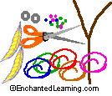

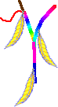 | Wind yarn around a y-shaped twig, covering it entirely. Start and end the winding with knots (or tape, if the children cannot make knots). Along the way, wind in a few decorative objects, like feathers or beads.

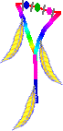 | Tie a short piece of yarn to one arm of the "y." Thread a few beads, washers, spools, or other small objects onto the yarn. Tie the other end of the yarn onto the other arm of the twig.

BOX GUITAR | 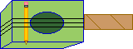
This is an easy way to make a guitar using an old shoe box or tissue box, rubber bands, scissors, a paper-towel tube, and a pencil.
 | - Find an old shoe box, tissue box, or other cardboard box.  - Have an adult cut an oval-shaped hole in the top.
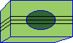 | Stretch a few rubber bands around the box and over the hole.
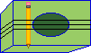 | Put a pencil under the rubber bands on one side.
 | Optional steps. Tape on a paper-towel tube and decorate the box.

Paper Plate Maracas Craft  A maraca is a Latin American and Tupi rattle. The original maracas were made from hollow gourds filled with pebbles or seeds.  You can make simple maracas from one or two paper plates stapled together, containing dried beans or popcorn. These are fun to make at a party for preschoolers - you can then make a lot of noise! | 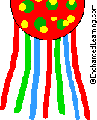

Supplies needed:
- One or two paper plates  - Dried beans, rice, or popcorn  - Stapler  - Paint, markers, or crayons  - Optional: crepe paper streamers | 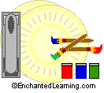

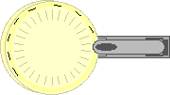 | Put a handful or two of dried beans, rice, or popcorn in a paper plate. Staple a paper plate securely on top of it.  [You can use a single plate for each maraca by folding a paper plate in half, adding the beans, then stapling the rim to itself.] | 

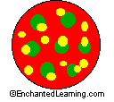 | Decorate the maracas with crayons, markers, or paint. | 

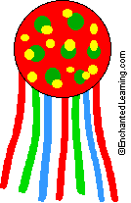 | Optional: Staple long crepe paper streamers to the maracas.  You now have great maracas that you can use to make music.

Musical Notes and Rests

