Theme:
Mother’s Day

Decorations:
WE LOVE OUR MOM signs throughout the park. Hearts, balloons, flowers.

Games & Activities:
- Free Brunch for Mom
- Schedule a manicure or pedicure for Moms
- Yoga session
- Secluded area just for Moms to relax

Kids Activities:

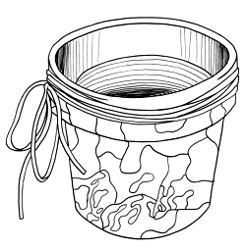
MOTHER'S DAY CRAFT

Objectives
A nifty, thrifty idea for mom.

What You Need:
- 8" terra cotta pot
- magazines
- decoupage or white craft glue
- raffia

What You Do:
- Instruct children to choose several different pictures from magazines, cut out pictures and organize on pot, it takes some children some time to arrange the pictures as they would like.
- Paint small surface where picture is to be placed with decoupage and adhere picture; continue until all pictures are on the pot.
- Make sure to instruct the children to only pick a few pictures and make sure they are the appropriate size as if some are too large they will not lay flat.
- After all pictures are on paint entire pot with decoupage (use two coats).
- When dry tie raffia around rim. If desired plant a pretty flower in it for Mom.

GARDEN ROCK
What You Need:
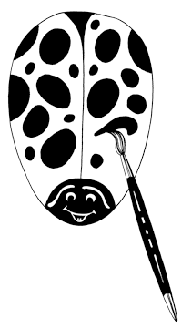
- Rocks
- Red and Black Tempera Paint
- Brushes
- Clear coat spray

What You Do:
- Children select rocks.
- Wash and dry rocks.
- Become scientists and discover how rock lies best.
- Paint rock red.
- While drying decorate Mothers Day Card.
May use this poem:
A ladybug
I've made with love
to set among your flowers
To let you know I love you
and appreciate your hours.
- Once card is decorated and red paint is dry add black features of ladybug.
- Let dry.
- Apply spray to preserve.
- Give Mom a lifelong garden gift she'll treasure!

MOTHER'S DAY GIFTS ON A KID'S BUDGET
Let Mom sleep late!
Clean your room - without being asked.
Offer to baby-sit for your little brother or sister (without being paid).
Ask Mom what she'd like you to do - take a walk with her, go for a picnic, wash her car?
Don't ask, 'What's for dinner?' Instead set the table and help Dad with the cooking - or, if you need help from an adult, ask a neighbor or older friend to help. The fact that you organized this meal will be most appreciated.
Feed the dog or clean the bird cage for one week.
Tell Mom you love her. Remember, the more things that you do for Mom, the more time she has to spend with you. And that's the gift that Moms love most of all.

MOTHER'S DAY FLOWER
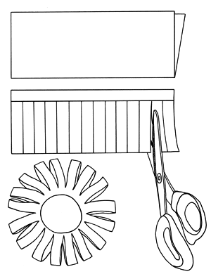
What You Need:
- 9" x 12" sheets of construction paper or any paper (even typing paper works)

What You Do:
- Fold a 9"x12" sheet of paper in halflengthwise.
- Mark a line 1" from the open edge across the width of the paper.
- Cut strips, about 1/2", from the folded edge up to the line
- Fold the two uncut edges together and roll the paper together lengthwise. A daisy shape will begin to appear.
- Fasten the paper together with glue, tape or staples.
- Repeat and make more flowers for mom.

Hint
Decorate the paper before you fold and cut it. Use crayons, magic markers or paint to create bright colorful designs.

MOTHER'S DAY PEANUT CARD
Objectives:
A great way to let mom know you are "nuts" about her.

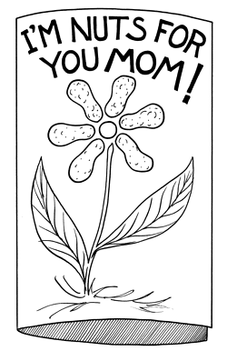
What You Need:
- Halves of peanut shells
- Tempera Paint
- Paint Brushes & Water
- Heavy paper
- Glue
- Pencils
- Crayons
- Glitter

What You Do:
- Paint the peanut shell halves nice bright flowery colors and let dry.
- Create a folded card with the heavy paper.
- Draw the beginnings of a flower (stem, leaves and center) on the front of the card.
- Glue the painted peanut shell halves on the card ... use them as the petals of the flower.
- Write "I'm nuts for you Mom" on the front of the card.
- Add glitter as an added extra.

Note
Before attempting this activity in a classroom environment, make sure there are no kiddos with peanut allergies in your care. If so, substitute pop bottle lids or milk caps for the peanut shells.
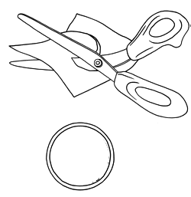

RECYCLED PHOTO FRAME

What You Need:
- concentrated juice tins
- photos
- magnetic strips
- scissors
- glue

What You Do:
For years my children have enjoyed having their picture taken with their friends. Being in the military, we have circled the globe but our refrigerators serve as our friendship photo album.
When we open a can of frozen juice, we save the tin and toss the cardboard.
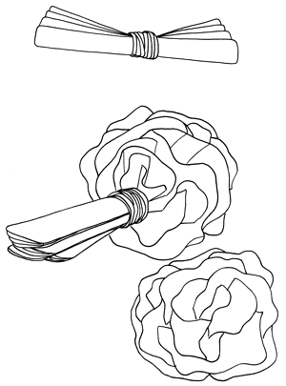
Trace the circle around a new picture, put 3 rows of magnetic tape on the back and we have a handy little fridge magnet and the tin protects the picture from all the hugs and kisses.

TISSUE PAPER CARNATIONS

What You Need:
- tissue paper squares
- twist ties

What You Do:
- First you take about 5 to 6 pieces of tissue paper squares, depending on the thickness of your desired depth of the flower.
- Stack all sheets together one on top of the other.
- Begin folding your paper back and forth like an accordion or a fan.
- When complete secure in the middle with a rubber band or twist tie.
- Now its time to peel up each sheet one at a time. Work from side to side, left to right.
- Bring all sheets to the middle until your done.
- If you want the flowers smaller cut the sheets down by length.
- To make different shapes clip off the tips, only a trim. (triangle, points, wavy, square, etc..)

WOVEN BASKET

What You Need:
- Plastic strawberry baskets
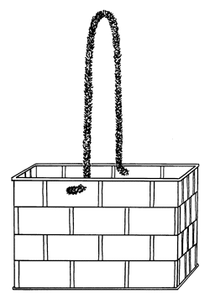
- Crepe paper streamers, ribbon, or strips of material.
- Pipe cleaners in assorted colors.

What You Do:
- Wash and dry the basket.
- Fold strips of crepe paper streamer lengthwise in half reducing it's width. Use roughly an arms length of streamer.
- If you want a nice bow, then start weaving from the middle of one side of the basket, with the middle of the ribbon. Weave one half then the other and stop at the opposite side, and tie a bow.
- Begin weaving the streamer/ribbon/material through the holes, any way you want.
- When done braid three different colours of pipe cleaners and attach to either side of the basket as a handle. Catch short pieces of crepe paper/ribbon/material into the braid for a nice effect.
- Fill the basket with whatever you like. I've made chocolates, felt, paper cup, egg carton flowers all with pipe cleaner stems.

