Theme:
Memorial Day Weekend
Memorial Day, originally called Decoration Day, is a day of remembrance for those who have died in our nation's service.

Usually people think of Memorial Day and Labor Day as the “bookends” of summer. On this note you should start this Holiday off with a bang.

Invite someone from the military to do a short skit, or say a few words commemorating those who died in our nation’s service. Make sure the flag is prominently displayed at this gathering.

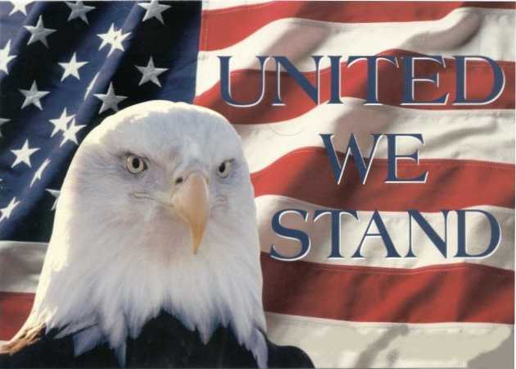

Decorations:
- Display this Henry Wadsworth Longfellow Poem somewhere:
Your silent tents of green
We deck with fragrant flowers;
Yours has the suffering been,
The memory shall be ours.

- Red White & Blue – Of Course
- Flags

Games & Activities:
- Set up a time each day to raise and lower the flag with some “TAPS” Music
- Honor the Vets – Sunday Morning Pancake Breakfast
- Have a parade through the park – displaying the red, white and blue

Kids Activities:

- Make a Memorial Day Windsock
- Kids Crossword
- Kids Peace Windsock

Memorial Day Kids Crossword
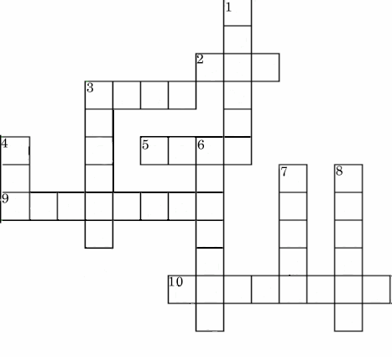

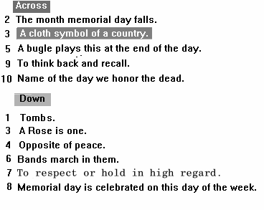

MEMORIAL DAY
KIDS Word Search
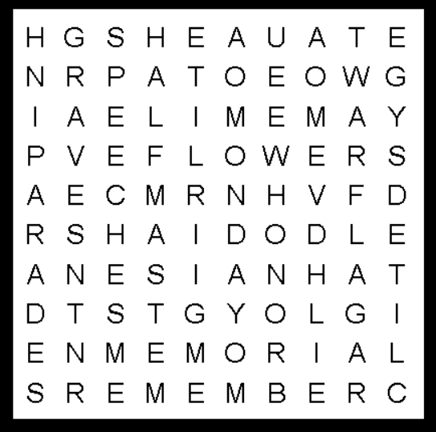

MAY | MONDAY | PARADES | GRAVES
FLAG | MEMORIAL | REMEMBER | HONOR
WAR | FLOWERS | SPEECHES | HALFMAST

