Theme:
4th Of July Weekend

Decorations: Anything Red, White & Blue, American Flags, Patriot Hats, Fireworks, Bursts

Games & Activities:
Over time, various other summertime activities also came to be associated with the Fourth of July, including historical pageants, picnics, baseball games, watermelon-eating contests, and trips to the beach. Common foods include hot dogs, hamburgers, corn on the cob, apple pie, cole slaw, and sometimes clam bakes.
The second president, John Adams, would have approved. "I believe that it will be celebrated by succeeding generations as the great anniversary festival," he wrote his wife, Abigail. "It ought to be celebrated by pomp and parade, with shows, games, sports, guns, bells, bonfires, and illuminations from one end of this continent to the other..."
- Patriotic Program
- 4th. Of July Parade
- Fireworks – Remember safety issues
- Picnic – with foods listed above
- Political Debate – Have one be George Washington and one be John Adams – go on the internet to find out what the issues were back then.
- Balloon Toss – Red, White and Blue of course – Fill with water – Pick teams and last team with unbroken balloon wins.

Kids Activities:

- See Patterns below for activities for the kids
- After they make their wands and hats – have a parade through the park – Could sing “This land is your land” as they go.
- Have kids color the patriotic pictures – Hang them up somewhere in the park
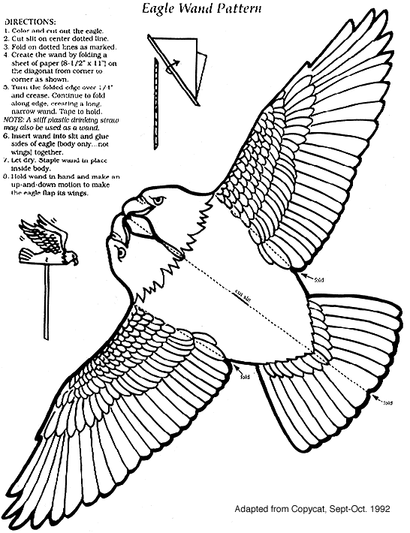
July 4
Sing- a-long
This land is your land,  This land is my land,  From California  To the New York Island,  From the redwood forest,  To the Gulf stream waters,  This land was made for you and me.  As I was walking,  That ribbon of highway,  I saw above me  That endless skyway,  I saw below me  That golden valley.  This land was made for you and me. | 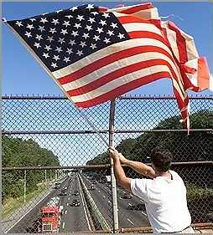
I've roamed and rambled
And I've followed my footsteps
To the sparkling sands of her diamond deserts
And all around me a voice was sounding
This land was made for you and me
The sun comes shining
As I was strolling
The wheat fields waving
And the dust clouds rolling
The fog was lifting a voice come chanting
This land was made for you and me
As I was walkin'
I saw a sign there
And that sign said no trespassin'
But on the other side
It didn't say nothin!
Now that side was made for you and me!
In the squares of the city
In the shadow of the steeple
Near the relief office
I see my people
And some are grumblin'
And some are wonderin'
If this land's still made for you and me.
Nobody living can ever stop me
As I go walking
That freedom highway
Nobody living can make me turn back
This land was made for you and me

Make (and decorate) a Militia Hat
("Old Sturbridge Village Kids", Summer 1997)
To make a man-sized militia hat, use a rectangle of paper about 20 by 24 inches. (For smaller heads reduce the piece of paper to about 16 by 19 inches--or maybe 10 by 12 inches for a doll.) Use any kind of foldable paper you want--even newspaper or wrapping paper--but plain paper is best if you want to paint or color your hat later!
- Lay the rectangle of paper down on the floor or table and fold edge AB onto edge CD (using fold line EF).
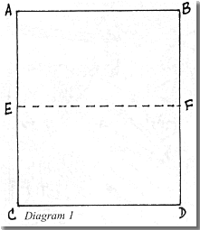
- Now fold the paper in half again (just to mark the center) and unfold to diagram 2.
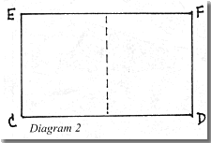
- Fold top corner E at a 45 degree angle, lining it up with the center line (diagram 3).
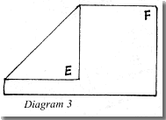
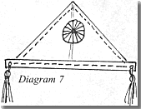
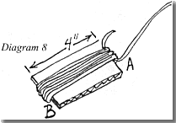
- Fold top corner at a 45 degree angle, lining it up with the center line (diagram 4).
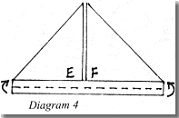

- Fold the top layer of the bottom edge only half-way up--so it comes up to the triangles you just made.
- Fold the bottom up one more time, so it now overlaps the two triangles (diagram 5).
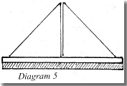
- Turn your hat over to the other side and repeat steps 5 & 6 with the remaining bottom edge.
- Glue or tape the bottom rectangles at corners C1 and C2 (diagram 6).
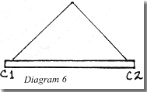
- Open up your hat and see if it fits. If not, start over with a larger or smaller piece of paper, but keep the same proportions (one dimension should be longer than the other!).
Adding Decorations
There are lots of ways to decorate your militia hat. How fancy you make it is up to you, but consider these options:
- cut some strips of gold or yellow paper less than a half-inch wide and glue them to the front and back according to the dotted lines on diagram 7. (Or just use crayons, paints, or yellow markers to add color to these areas of the hat!)
- make tassels by taking yellow yarn and wrapping it 15 or 20 times around a 4-inch wide piece of cardboard. Slip a 12-inch piece of yam under the wrapped yam at A (diagram 8) and tie a tight knot. Use scissors to cut all the ends of
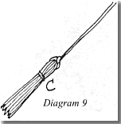
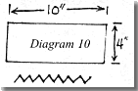
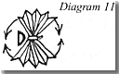
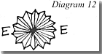

the yarn at B. Remove the cardboard. Wrap the yarn at C with a scrap of yarn (diagram 9) and tie it. This is a tassel. Make two for your hat. Punch holes at corners C1 and C2 and tie the tassels in place.
- make a "cockade" by taking a piece of gold or yellow paper 4 inches wide by 8 or 10 inches long. Pleat it (fold it one way, then the other) every 1/4 inch (diagram 10) so it looks like an accordion. Pinch all the pleats together and tie them in the middle (diagram 11). Fan out (open up) the pleats in both directions until you form two half-circles. Tape or glue the edges at E (diagram 12) to keep the pleats in a circle. Sew or glue the finished cockade over the center fold of your hat, being careful not to go through to the other side if you're sewing.
Now, put your hat on and see who salutes! (Wear your hat to the Village's Independence Day Celebrations on July 4th - you'll fit right in; or bring it to our July 5th Kids Fair and we'll teach you to march in the Kids Club Militia!)

