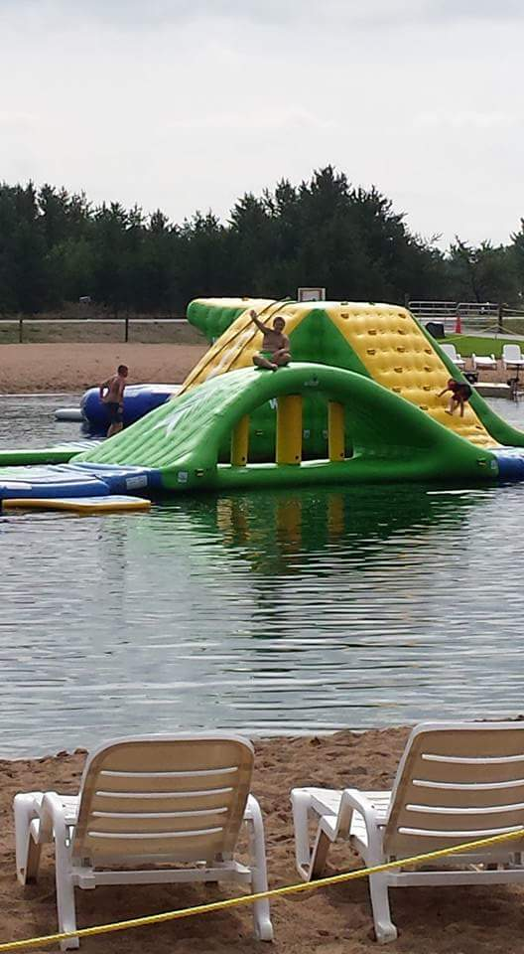
The Place Where Family Memories are Made!

2018 River's Edge Weekend Activities
April 20th-April 22nd
Clean up weekend/Welcome back Seasonal’s Party
April 27th-April 29th
Hillbilly/Redneck Weekend
May 4th-May 6th
Cinco De Mayo/Star Wars Weekend
May 11th-May 13th
Woodstock/Mother’s Day
May 18th-May 20th
Salute to Hero’s
May 25th-May 28th
Memorial Day
June 1st-June 3rd
Site Rummage sale/Flea Market/Craft Show
June 8th-June 10th
Prom Weekend/Bullheads Anniversary
June 15th-June 17th
Father’s Day- 80’s throwback
June 22nd-June 24th
Pirates and Princesses
June 29th-July 8th
4th of July Celebration
July 13th-July 15th
Carnival Weekend
July 20th-July 22nd
Christmas in July
July 27th-July 29th
Vegas Weekend
August 3rd-August 5th
Rockabilly/Car Show
August 10th-August 12th
Luau
August 17th-August 19th
Boat Races
August 24th-August 26th
Water Wars
August 31st-September 3rd
Labor Day
September 7th-September 9th
Halloween I
September 14th-September 16th
Halloween II
September 21st-September 23rd
Zombie Weekend/Zombie 5K
September 28th-September 30th
Game Day
October 5th-October 7th
Oktoberfest
October 12th-October 14th
Around the World/Seasonal Year End Party

Our staff is dedicated to providing our guest with an enjoyable and memorable experience. To experience our hospitality, for more information on booking and rates visit www.riversedgewisconsin.com

Our staff is dedicated to providing you with an enjoyable and memorable experience. To experience our hospitality get rates and booking information at www.riversedgewisconsin.com
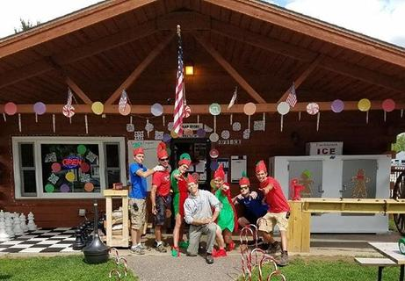

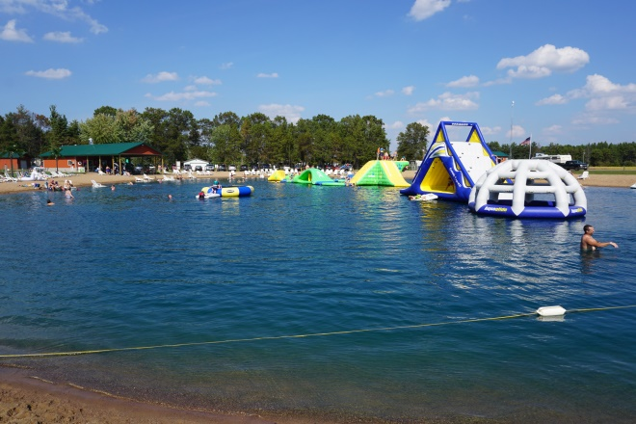

Waterpark passes
Our waterpark is open daily from 9:00 A.M. to Dusk
Waterpark passes are included with your campsite for up to 4 people. Each additional pass is $10.00 for your stay.
We are open to the public for day passes Sunday-Friday $10 per person.

Birthday parties and Large Groups
We can accommodate large groups with special pricing. Great for birthdays, company parties, special events and church and school outings. This special pricing is available weekdays only. Advance reservations are required.

Our Season
We are normally open from May 1st to October 15th, weather permitting. We begin taking reservations January 1st. We require full payment at the time of reservation. For seasonal details and special rate announcements visit us online at www.riversedgewisconsin.com

On Site Conveniences
Sites accommodate most RV’s
Full Hookups
Boat Landing
Picnic tables and Firepit on each site
Bar & Grill
Campstore
Pavilion
Concessions Stand
Clean Restrooms
Coin Operated Showers
Coin Operated Laundry Room
WIFI available for an additional fee
Volleyball and Basketball
Playground

Every Weekend is a Themed adventure with activities and Crafts. For more information on themed weekends visit www.riversedgewisconsin.com

RV’s of all Sizes are welcome at River’s Edge
With both 30 and 50 amp hookups, back in and pull through sites, and full hookups your home on wheels will be easily accommodated
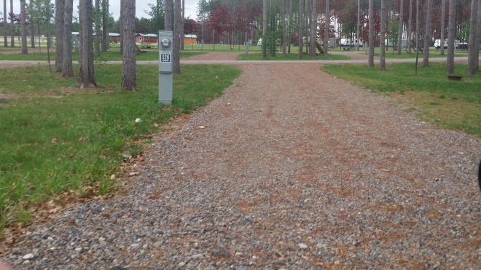

Rental Units to accommodate any traveler
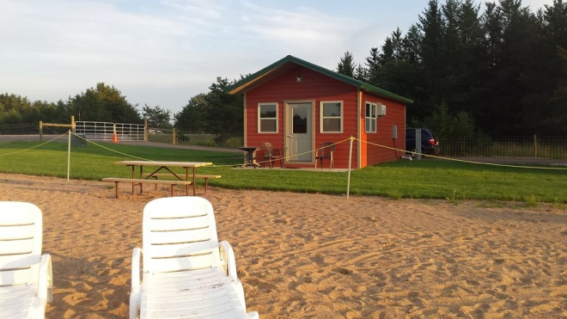
We can provide lodging for just about any family.
From beachside 2 bedroom cabins, rental campers, and our large family River’s Edge Lodge, we have you covered!

